Day-5 mongoDB Assignment:
>use insuranceDB
1.customers:
db.customers.insertMany([
{
_id: 1,
firstName: "Ravi",
lastName: "Kumar",
dateOfBirth: ISODate("1995-06-15"),
phone: "9876543210",
email: "ravi@gmail.com"
},
{
_id: 2,
firstName: "Anita",
lastName: "Sharma",
dateOfBirth: ISODate("1992-03-20"),
phone: "9123456780",
email: "anita@gmail.com"
}
])
Agents
db.agents.insertMany([
{
_id: 101,
agentName: "Suresh",
phone: "9000011111",
city: "Hyderabad"
},
{
_id: 102,
agentName: "Meena",
phone: "9000022222",
city: "Bangalore"
}
])
Policies
db.policies.insertMany([
{
_id: 201,
policyName: "Health Plus",
policyType: "Health",
premiumAmount: 15000,
durationYears: 1
},
{
_id: 202,
policyName: "Life Secure",
policyType: "Life",
premiumAmount: 25000,
durationYears: 5
}
])
Policy Assignment
db.policyAssignments.insertMany([
{
_id: 301,
customerId: 1,
policyId: 201,
agentId: 101,
startDate: ISODate("2024-01-01"),
endDate: ISODate("2024-12-31")
},
{
_id: 302,
customerId: 2,
policyId: 202,
agentId: 102,
startDate: ISODate("2023-01-01"),
endDate: ISODate("2028-12-31")
}
])
Claims
db.claims.insertMany([
{
_id: 401,
assignmentId: 301,
claimDate: ISODate("2024-06-10"),
claimAmount: 50000,
claimStatus: "Approved"
},
{
_id: 402,
assignmentId: 301,
claimDate: ISODate("2024-09-15"),
claimAmount: 20000,
claimStatus: "Pending"
}
])
Find commands
1.db.customers.find({ firstName: /^A/ })

2.db.customers.find({
dateOfBirth: { $gt: ISODate("1993-01-01") }
})
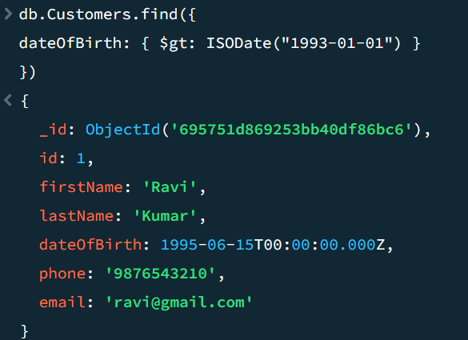
db.customers.findOne({ _id: 1 })
8.Update command
db.customers.updateOne(
{ _id: 1 },
{ $set: { phone: "9999999999" } }
)
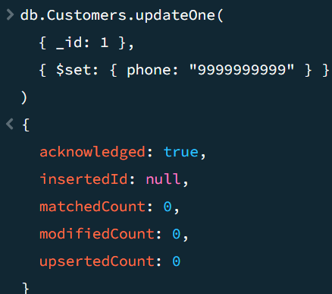

9.update many
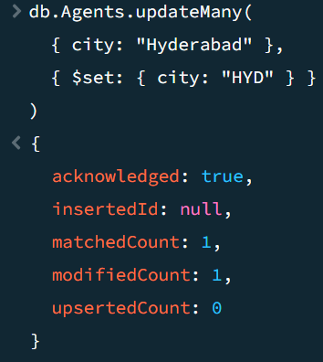
10. Delete command
db.customers.deleteOne({ _id: 1 })
11. Delete Many command
db.agents.deleteMany({ city: "HYD" })
12. Count & Sort
db.customers.countDocuments()
db.customers.find().sort({ firstName: 1 })
13. Limit & Skip
db.policies.find().limit(2)
db.policies.find().skip(1).limit(2)
14. Drop
db.claims.drop()
db.dropDatabase()

15. Find policies with premium >20,000
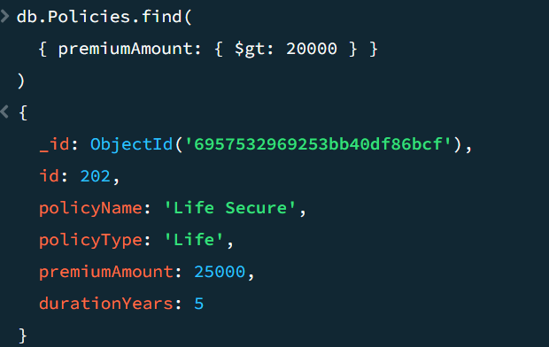
16.Sort policies by premium (high → low)
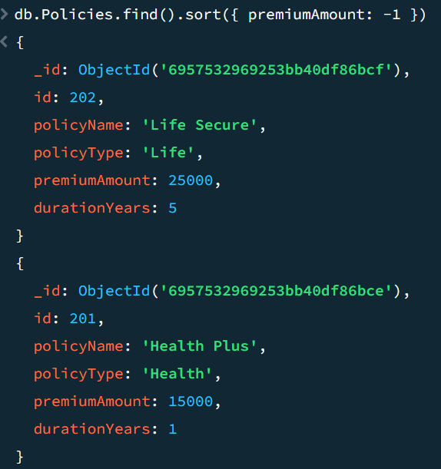

17. Find policies of type "Health"
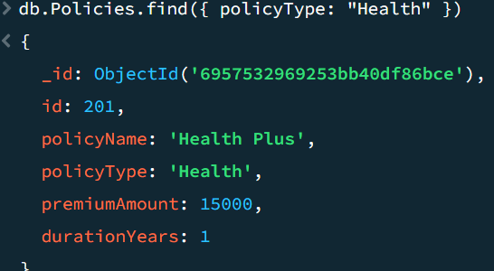

18. Count policies per customer
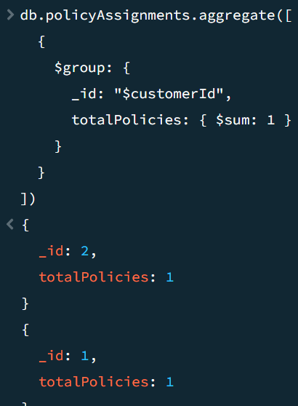
19. Total claim amount per policy assignment
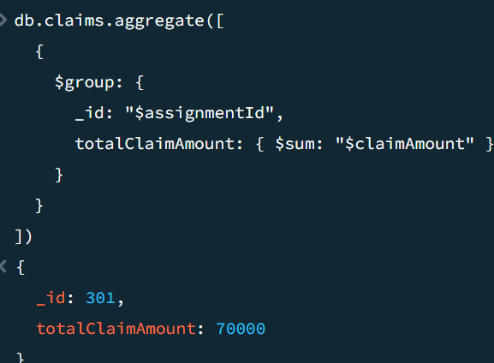

20.Total claim amount
